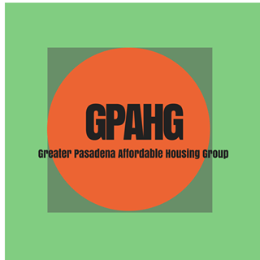
Greater Pasadena Affordable Housing Group (GPAHG)
Liaison Form

Vision: All Pasadena residents shall have safe, quality, accessible, and affordable housing; people are not displaced from the community, and our community is racially, ethnically and socially diverse.
Mission: GPAHG educates, advocates, and acts to promote safe, clean, and affordable housing for low, very-low, and no-income residents of the greater Pasadena area.

Name: ________________________________________Email: _____________________________________
Phone (home and cell):_______________________________________________________________________
Address: __________________________________________________________________________________
City and zip: ______________________________________________________________________________
Occupation (s): __________________________________ Birthday: ___________________

Organization’s Name: ________________________________________
Phone: _______________________________________________________________________
Address: __________________________________________________________________________________
City and zip: ______________________________________________________________________________
Pastor/Leader’s Name: __________________________________ Email/Phone: ______________________

What are you and your organization’s concerns and interests around housing issues?

Have you attended a GPAHG orientation? Yes or No
May we use your organization’s name and logo on GPAHG general brochure/website? Yes or No
I understand that as a liaison I represent my organization’s and am committed to nurturing a partnership between GPAHG and my organization in some of the following ways:

Rally 5 to 10 people from organization to participate in campaigns/meetings, especially as part of a rapid response when needed.  Help set-up meetings with key leaders such as a pastor to explore ways the organization may want to be involved. | - Determine your organization’s interest and needs  concerning housing  - Share information and/or make announcements at your organization on behalf of GPAHG | - Personal commitment to learning some of the complexities and barriers to making housing happen and how to overcome those barriers. | - Attend GPAHG monthly meetings  - Recommended Annual donation of $50 or more per year from organization

Pastor/Leader’s Name: __________________________ Signature: __________________________ Date: _______
We plan to have a meeting with you the liaison, and your congregational or organizational leader for a brief orientation when he/she will sign this. Please let us know the best way to reach you and the leader of your organization and some of the best times to meet: ___________________________________________________________________________________________________

