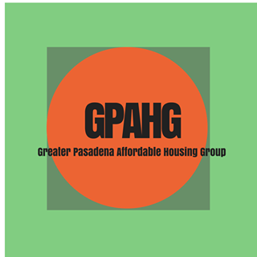Greater Pasadena Affordable Housing Group (GPAHG)
Membership Form

Vision: All Pasadena residents shall have safe, quality, accessible, and affordable housing; people are not displaced from the community, and our community is racially, ethnically and socially diverse.
Mission: GPAHG educates, advocates, and acts to promote safe, clean, and affordable housing for low, very-low, and no-income residents of the greater Pasadena area.

Name: ________________________________________Email: _____________________________________
Phone (home and cell):____________________________Date:
Address: __________________________________________________________________________________
City and zip: ______________________________________________________________________________
Occupation (s): __________________________________ Birthday (Date and Month: ___________________

Indicate if you are representing an organization: Organization Name: _____________________________
Prior experience with housing issues:
___________________________________________________________________________________
What strengths or skills you have that you would like to share?
___________________________________________________________________________________
What is your area of interest?
___________________________________________________________________________________
______Affiliate Member: Agree with GPAHG’s vision and mission. Be on our email list, receive our newsletter, attend the larger campaigns and write letters and/or make public comment at City Council or various Commission meetings. Participate in aspects of active membership as time may allow.

______Active Membership: Become a voting member. Same criteria as an Affiliate Member plus attend monthly meetings and support GPAHG platform (see attached). Additionally, you may sign up for one or more of the activities or committees below.

- Be a note taker
- Help to create the agenda
- Set up appointments with city leaders
- Monitor Planning Commission agendas
- Monitor City Council meetings
- Monitor ED TECH meetings
- Plan location of meetings
- Facilitator or timekeeper
- Monitor Ed Tech meetings (subcommittee of City Council) for housing issues.
- Help with designing a Website, Facebook, Twitter, database
- Bring snacks
- Education for New Members: Creating new member packets, Affordable housing tours, plan monthly education sessions
- Send out meeting reminders/call
- Do a devotion
- Share your housing story

Join committee: (circle the one you are interested in)
- ADU—Accessary Dwelling Unit (Granny Flats)
- Homeless housing--Permanent Supportive Subcommittee—support projects in every district.
- Inclusionary Zoning
- Safe Parking
- Using Church land
Mail to GPAHG, c/o Jill Shook, chair, 1628 N. Garfield Ave, Pasadena, CA 91104, or Email jill@makinghousinghappen.com

